- 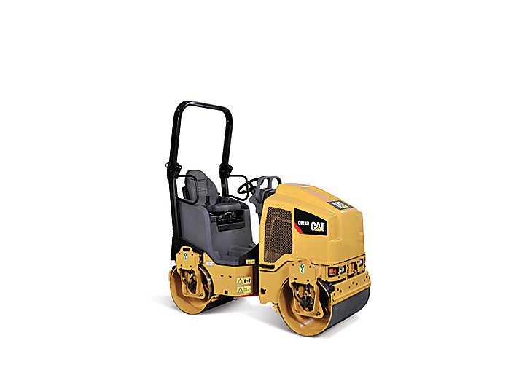
- 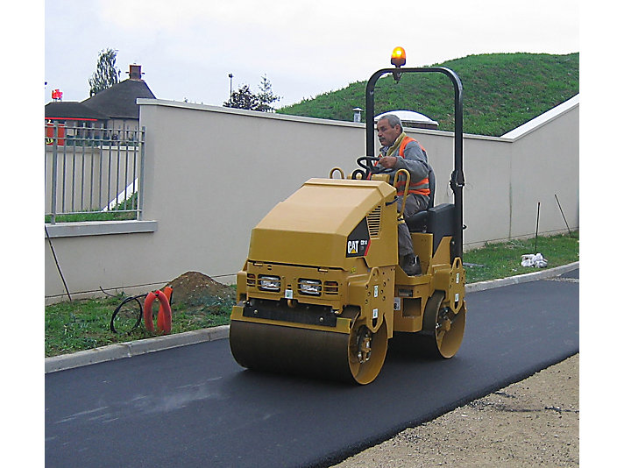
- 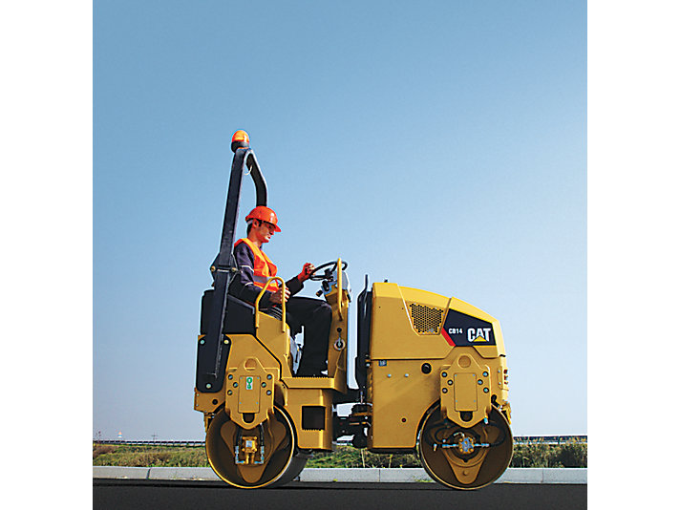
- 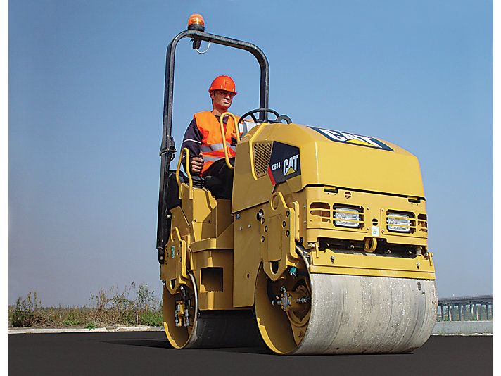

SPECIFICATIONS

OVERVIEW
The CB14 provides the reliability and versatility that you've come to expect from Caterpillar.

WEIGHTS
UNITS:
- US
- METRIC
Operating Weight | 1620.0 kg
Maximum Weight at Front Drum | 740.0 kg
Maximum Weight at Rear Drum | 880.0 kg

OPERATING SPECIFICATIONS
Standard Compaction Width | 800.0 mm
Curb Clearance | 370.0 mm
Turning Radius Inside Drum Edge | 2650.0 mm
Ground Clearance | 250.0 mm
Static Linear Load | 10.1 kg/cm
Travel Speed – Maximum | 8.5 km/h

ENGINE
Gross Power | 16.1 kW
Engine Model | C1.1

DIMENSIONS
Overall Length | 2050.0 mm
Wheelbase | 1300.0 mm
Height at Steering Wheel | 1630.0 mm
Overall Width | 884.0 mm
Drum Diameter | 575.0 mm
Drum Width | 800.0 mm
Maximum Machine Height | 2400.0 mm

VIBRATORY SYSTEM
Frequency | 53.3 Hz
Centrifugal Force per Drum – Maximum | 10.3 kN
Nominal Amplitude – High | 0.4 mm

SERVICE REFILL CAPACITIES
Fuel Tank Capacity | 30.0 L
Water (Spray) Tank Capacity | 150.0 L

BENEFITS & FEATURES

EQUIPMENT

